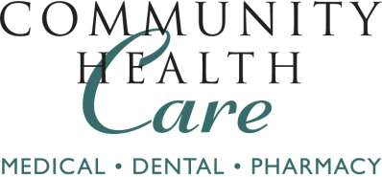
CHC Hilltop Medical Clinic
1202 Martin Luther King Jr. Way
Tacoma, WA 98405-3926
Phone: (253) 441-4742
Fax: (253) 442-8790

_

October 18, 2018

Re: Nicole Hahn
DOB: 03/09/1971

To Whom it May Concern:
I am a family medicine physician licensed to practice medicine in the state of Washington. Nicole Hahn is a patient in my practice. She has a long history of persistent gender dysphoria and has been evaluated for the capacity to provide informed consent. She has no significant uncontrolled medical or mental health conditions. She has been on hormone therapy for 12 continuous months under my care. I recommend her for orchiectomy.
Sincerely,

Constance Blair Campbell MD
License # 60463468

